# Market Definition and Entry Strategy

* The effort of new product development has two major steps
  + Markets and their associated technologies are defined and opportunities within them are assessed
  + Specific ideas are generated to tap the potential of these markets and the firm’s competitive advantages
  + When the opportunity identification phase is compete, design work begins based on evaluation and refinement of the idea as a physical and psychological entity that delivers benefits to customers

## Desirable Characteristics of Markets

* Success is likely in markets
  + High sales potential
  + Can be entered early
  + Are competitively attractive
  + Can generate economics of scale
  + Require small investments for large reward
  + Low risk

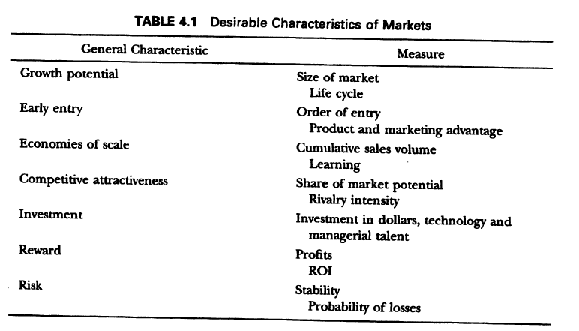

### Growth Potential

* Measured by the size of the market in dollar sales and growth rate of the market
* Key to identify a new opportunity
* A growing market is also one where prices and margins are higher and therefore more desirable

### Market sizing

* To assess the growth potential of a market, a forecast and an understanding of the position of the market in its life cycle are required

### Market growth model

* Useful in predicting the future sales of a product class based on the past sales history of the products
* The model is based on the assumption that the probability rate of initial purchase at a given time is a linear function of the total number of previous buyers
* Initially, the probability rate would depend on innovators, but would increase over time as the number of past buyers increases
  + Mathematically, this model implies that the rate of purchases is equal to an initial value due to innovators plus a term that reflects that impact of the word of mouth influence process
  + This latter term is equal to a constant times the fraction of customers who have already purchased the product
* 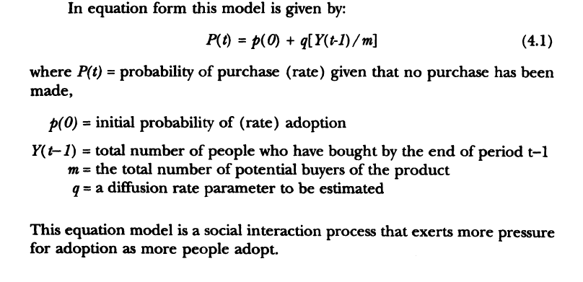
* 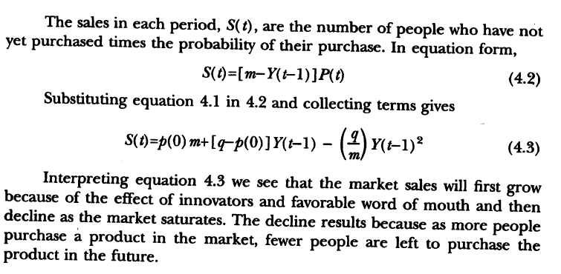
* The shape of the function is similar to the life cycle
* The model does not represent replacement after the product wears out
* The model helps establish the initial growth rates for a category and hence the attractiveness to new-product entry
* The use of this model in market definition is for the growth rate of a market not a specific product

### Use of Models to Forecast Growth

* The available models are effective in predicting life-cycle growth when six or seven years of data are available in the category
  + Alternatively, an analogy can be drawn to a market where the parameters (p(0), q, and m) are know
* In these cases, the use of a growth model is superior to naïve straight-line extension of past sales
  + However, one should be sure to understand the determinants of the curve and be sure the assumptions of the model are met before the forecasts are adopted
* Most of the life-cycle forecasting research has been done on consumer durables and industrial products
  + But recently the models have been extended to capture the effects of successive generations of technological innovations
  + If a market is completely new and in an industry where the model has not been applied, either judgment will have to be used or a market research study executed to estimate the market potential

### Early Entry

* All else being equal there are rewards for being first into the market if the new product is successful
* There are several explanation for this advantages
  + Entry barriers
  + Brand consideration
  + Cognitive advantages
    - The organization of information in long-term memory controls the accessibility and availability of that information in decision making
    - If the first entrant creates a node and becomes an exemplar for the product category then information about competing products may be referenced through comparison to the exemplar
      * Memory access will evoke the exemplar first, producing a competitive advantage

### Experience curve

* Cumulative sales volume is important because of the presence of the potential to improve production in many industries
* This curve indicates that for many manufacturing industries the unit cost of producing and distributing a product declines at a constant rate for each doubling of the cumulative scales y the firm
* Advantages in cumulative production can be gained from dominant share positions as well as early entry
* If experience curve exists, high market share in a large market is a good way to move to lower unit costs
* Large share in a market gives a firm relative strength and dominance in that market and hence control over strategy in the market
  + Improve the flexibility of action that can lead to increase profitability

### Competitive attractiveness

* Although a market is growing, has few entrants, and is subject to economics of scale
* May not be a good opportunity if
  + The competitive environment is hostile
  + A strong share position cannot be obtained
* Competitive attractiveness is reflected in the competitive aggressiveness of a market as well as its vulnerability
  + Price competition is less attractive

### Investment

* The more investment required by a market for entry and penetration, the less attractive it is
* Besides direct financial investment, and organization must consider the allocation of its other scarce resources such as managerial talent, capital equipment, and laboratory resources, which represent an indirect financial investment

### Reward

* Large investments in themselves are not unattractive if they lead to high returns on investment
* The profitability must be considered rather than sales volume or investment alone
* Large investment entry costs may act as barriers to discourage competitive entry and as a result could lead to long-term profitability
* Organizations with competitive strength may be advised to consider markets with high entry costs

### Risk

* Markets characterized by uncertainty are less attractive
* If demand is unknown or subject or rapid and large fluctuation the resulting risk of new product failure is high
* An organization must examine a market for characteristics of risk
* Judgmental estimates or historic observations of the probability of failure and the variance in payback can be used to evaluate the risk of a given market

## Market profile analysis

* The seven criteria discussed are used to evaluate the desirability of a particular market
* It is rare that a market will dominate all others on all criteria
* An organization must have some procedure by which to select markets based on these conflicting objectives
* Three steps of market profile analysis
  + Enumerate and weigh the market selection criteria for your organization
  + Rate each market on each criterion
  + Calculate the overall weight sum of the ratings for each markets
  + Evaluate the ratings to identify the market with the best opportunities for continued investigation. Those with very low ratings are eliminated

## Enumerate and weigh criteria

* First step is to generate the criteria that are important in a given organization
  + Done by managerial discussion
  + Interaction to specify the important factors in the words of the organization’s management
* There are many possible enumerations of factors
* Although many lists can be found, each organization should go through the exercise of developing its own list or customizing existing lists of factors
* One aspect that will characterize technologically based companies is the match of the market to the organization’s technologies and core markets
  + It is common in such companies to define core technologies and core markets
* Even of the environment is good, it does not mean that there is opportunity unless the core technologies are used
* This matching of technology and market focus in this firm is very important in screening new-product development projects and developing competitive technological advantages in focused markets

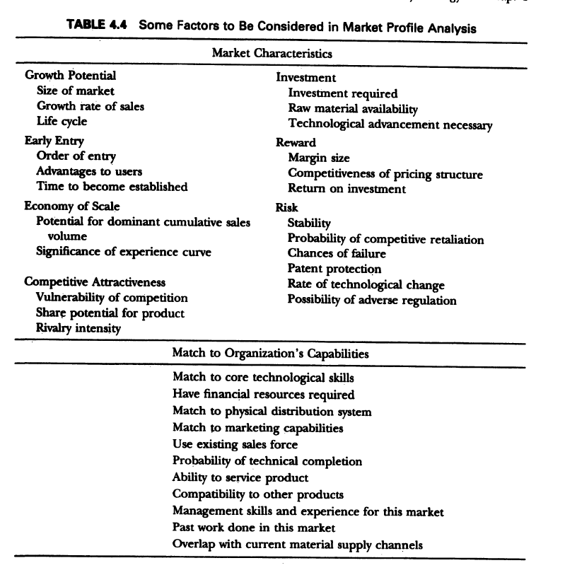

## Weighing

* This step is necessary to converting the checklist into a market profile analysis
* The major headings are a relative weight, and then the heading weight is divided among the component parts
* It is a valuable exercise for the organization in terms of structuring and setting market priorities
* A factor is so important that it must be satisfied before a market can be considered
  + Such elimination criteria are considered by eliminating all markets that do not meet the criteria and then evaluating the remaining markets with the remaining factors and weights
* The judgemental weighing can be improve by technical methods if the factors are independents
  + Most of the gain from weighing Is due to discussion among managers that directs attention to various markets and assures a systematic first look at them
  + Many of the factors are not independent; a factor that appears to make market unattractive may actually make it attractive if it matches a firm capability that can be converted into a competitive advantage

## Rating

* Given the preceding caveats, it is still worthwhile to rate judgmentally each alternative market opportunity on each factor
* The rating can be done with 5-point scale relative to an average existing market for the firm

## Overall evaluation

* Combine the ratings, identify the market with the best overall appeal, and eliminate undesirable markets
* This is done judgmentally by examining the profile of ratings on each factor for alternative markets
* In some cases
  + Aided by calculating an average overall score for each market by multiplying the rating on each factor by that factor’s importance and adding these for each factor
  + The markets with the highest scores are most desirable
* Try a few alternative weightings or rating schemes to determine how sensitive the priorities are to the chosen procedure
  + Managers can then re-examine the markets sensitive to the selection of evaluation procedures
* If a formal rating and weighting system issued, the firm should keep records of individual judgments
  + These judgments are compared to actual results in markets where products are entered
  + The comparison will indicate biases in the ratings of certain individuals or by the representatives of specific functional areas
  + The comparison is for the future evaluation
* The output of the overall evaluation is a set of high potential markets worth further investigation plus a preliminary set of priorities to guide that investigation

## Market Definition

* It is desirable to have a large share of a big market, but it is possible to build a business based on a small overall share if that small share reflects a high penetration in some market segment
* Rarely is it profitable to have a product with a low share in all segments
* Market definition relates to the new product’s relationship to existing products of the firm
  + If the new product in the same market as an existing market, cannibalization could result
* In proactive new-product design, management must be very purposive in defining the boundaries of the market they are entering
* Methods or factors for selecting the markets
  + Demographics
    - Demographic also reveal the future opportunity
  + Attitudes
    - Attitudes provide another means to segment customers
    - Linked to demographic variable as well as preferences
  + Preferences with respect to product benefits
  + Price sensitivity
  + Decision rules
  + Usage
  + Product form
  + Competitive products
  + Multiple perspectives

## Methods for market definition and segmentation

* Two most common analysis
  + Cluster analysis
  + Substitution among products

### Cluster analysis

* Formed by matching those who have similar responses to the questions asked
  + Usually similarity between consumers is based on a formula
* Clustering methods choose clusters of consumers such that consumers within a cluster are similar and such that consumers in one cluster are dissimilar from consumers in other clusters
* The output can take the form of a hierarchical tree or an assignment of consumers to distinct groups

### Substitution among products

* If we know which products compete with one another, then we can use that information to uncover opportunities and design a product that is superior to existing products with respect to fulfilling customer needs
  + Alternatively, by understanding the limits of existing products we might be able to develop an entirely new product form and open a new market
* Substitution in use
* Processing sequence
* Product switching
* Product consideration